Template:

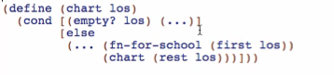

Rules used:

* One of: 2 cases
  + Atomic distinct empty
  + Compound: (cons School ListOfSchool)
* Reference: (first los)
* Self-reference: (res los)

Code body:

Base case:

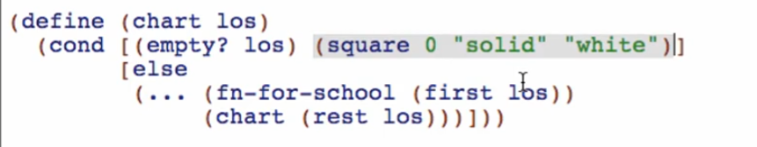

Reference case: fn-for-school

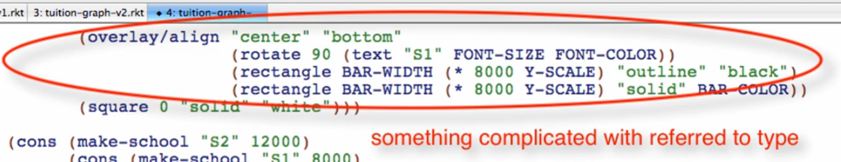

Natural helper

* Do something complicated in a helper function that consumes the referred type
* Do something elsewhere, not in the main function
  + Call an existing function or wish for a new one

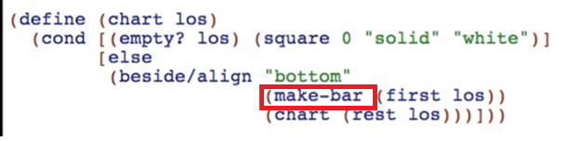

Write the wish list entry for make-bar

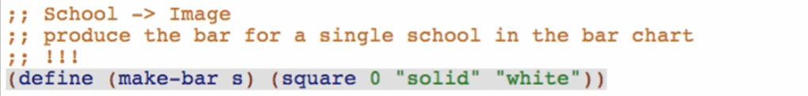

At this point, “chart” function is already done. We only need to finish “make-bar” helper function

Working through the wish list: make-bar

Examples:

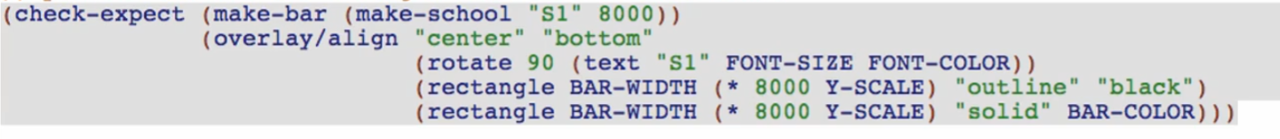

Template: (from data definition of School)

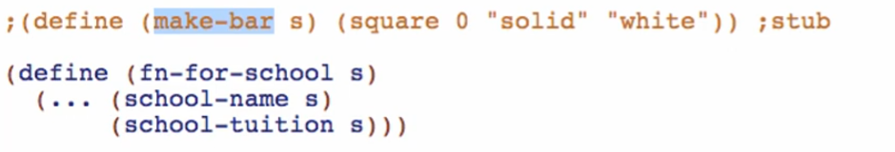

Rename fn-for-school

Code Body:

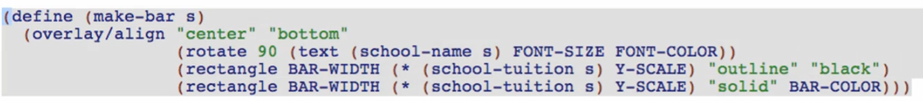

Test and debug:

 